**Problem 1:**

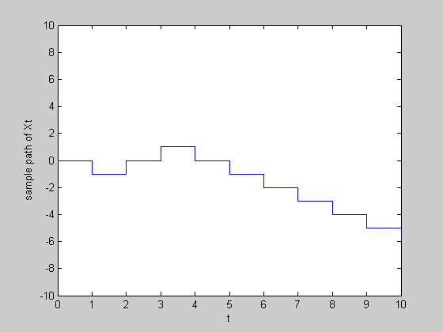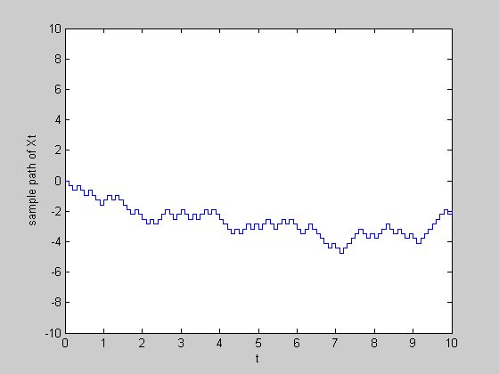

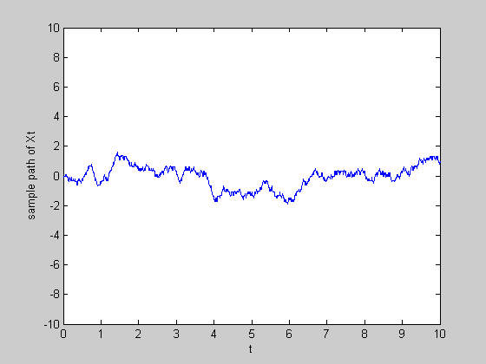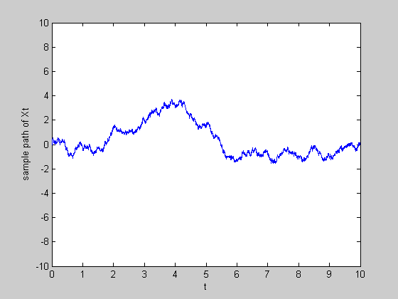

Figure 1: Sample path of Xt for alpha=1 and T=1, 0.1, 0.01, 0.001 respectively

Then, I generate 20 sample paths for T=0.001 and display them on the same plot. You can see the variance of sample paths approximately follow the linear trend.

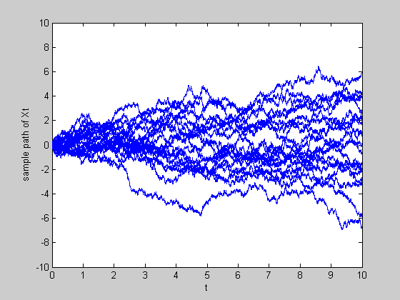

Figure 2: Sample path of Xt for alpha=1 and T= 0.001 respectively for 20 times

**Code:**

clear all; close all;

alpha = 1.0;

%T = 1;

% T = 0.1;

% T = 0.01;

T = 0.001;

s = alpha*sqrt(T);

samples = 20;

n = 10/T;

for k = 1:20

for i=1:n

z(i)=(2*floor(2*rand)-1)*s;

end

x= cumsum(z);

x=[0 x];

t=0:T:10;

stairs(t,x);

hold on;

axis([0 10 -10 10]);

xlabel('t');

ylabel('sample path of Xt');

end

**Problem 2:**

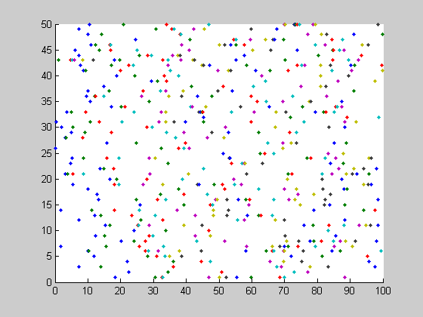

Figure 3: Generate homogenous Poisson process

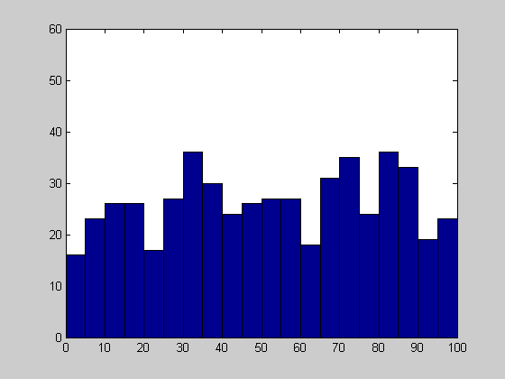

Figure 4: Histogram of the random variables

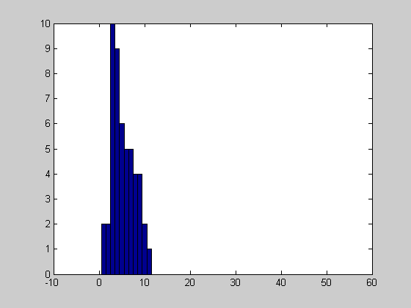

Figure 5: Histogram of 50 realizations of the random numbers occurring in [10,60]

r =

Columns 1 through 10

9 3 2 4 7 7 4 5 6 3

Columns 11 through 20

7 4 8 6 5 10 4 3 11 5

Columns 21 through 30

3 4 5 6 1 4 3 3 6 3

Columns 31 through 40

9 1 8 7 2 9 8 3 3 4

Columns 41 through 50

5 8 9 7 4 10 5 3 6 4

We apply the Kolmogorov-Smirnov test to check whether the sample follow a Poisson distribution, the result we get it they follow distribution with the p-value 0.1837.

>> h

h =

0

>> p

p =

0.1837

**Code:**

clear all;close all;

lambda = 0.1;

T=100;

M=50;

%%%Method 1 for generating 50 samplepaths from exp(0.1)

for i=1:M

x = exprnd(1/lambda, 2*lambda*T,50);

y(:,i)= cumsum(x(:,i));

y=y(:,i);

PP{i} = y(y<T);

hold on,

figure (3);

plot(PP{i}',i,'.');

end;

%%%%Method 2 for generating 50 sample paths from exp(0.1)

% for i=1:M

% n(i)=Poissrnd(lambda*T);

% x=rand(1,n(i))*T;

% PP{i}=sort(x);

% hold on,

% figure (1);

% plot(PP{i}',i,'.');

% end

figure(4);

HPP = [];

for i = 1:M

HPP = [HPP PP{i}'];

end

hist(HPP,2.5:5:97.5);

ylim([0 60]);

figure (5);

for i=1:M

r(i) = sum(PP{i}>10 & PP{i}<60);

end;

hist(r, 0:50);

%check whether sample follows Poisson distribution(KS test)

mu = mean(r);

x = 0:50;

est_cdf = poisscdf(x, mu);

[h,p] = kstest(r, [x' est_cdf']);

**Problem 3:**

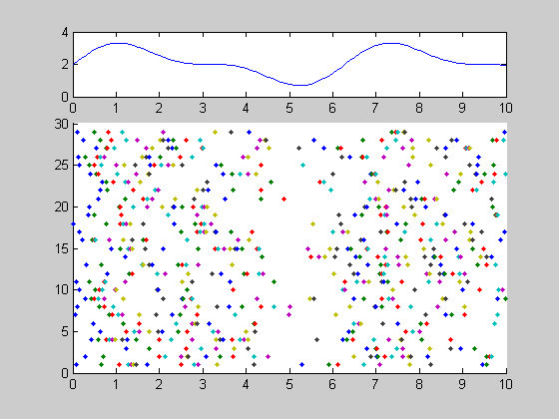

Figure 6: Rate function and sample paths for the inhomogeneous process

**Code:**

clear all; close all;

T = 10;

M = 30;

t = 0:0.1:T;

lambda = 2 + sin(t) + sin(2.*t)./2;

% display rate function

subplot(4,1,1);

plot(t, lambda);

F = inline('5/4 + 2*s - cos(s) - cos(2*s)/4');

DF = inline('2 + sin(s) + sin(2*s)/2');

for i=1:M

n(i) = poissrnd(1*F(T));

x = rand(1,n(i))*F(T);

npp{i} = sort(x);

%Newton-Raphson algorithm to estimate F^(-1)

for j = 1:length(npp{i})

x = T/2; % initial position

ind = 0;

while ind < 100

ind = ind+1;

x_new = x - (F(x)-npp{i}(j))/DF(x);

d = abs(x_new-x);

if d<1e-6;

break;

end

x = x_new;

end

ipp{i}(j) = x;

end;

end;

for i = 1:M

subplot(4,1,2:4)

hold on;

plot(ipp{i},i,'.');

end;

**Problem 4:**